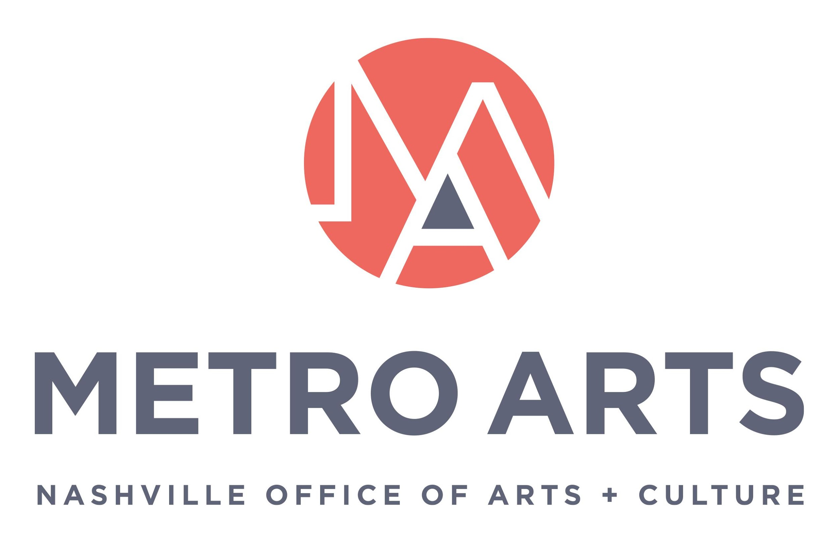

AGENDA
Committee for Antiracism and Equity Meeting
October 6, 2021 5:00-6:30 p.m.
Parthenon
Centennial Park
2500 West End Ave, Nashville, TN 37203

- Call to Order and Recognize Group Norms & CARE purpose statement

- Approval of Minutes: September 1, 2021

- Discuss developing a process to manage and prioritize committee workload

- Discuss Commission request that CARE review all policy documents before approval

- Review Temporary Art (on Metro Property) Guidelines

- Update on Equity Lens and Review of Metro Arts Cultural Equity Statement

- Discuss CARE statement

- Review CARE succession planning/upcoming vacancies/draft application

- Staff/ED/Commission Report

- Review Caucusing Process and Planning

- Adjourn meeting

