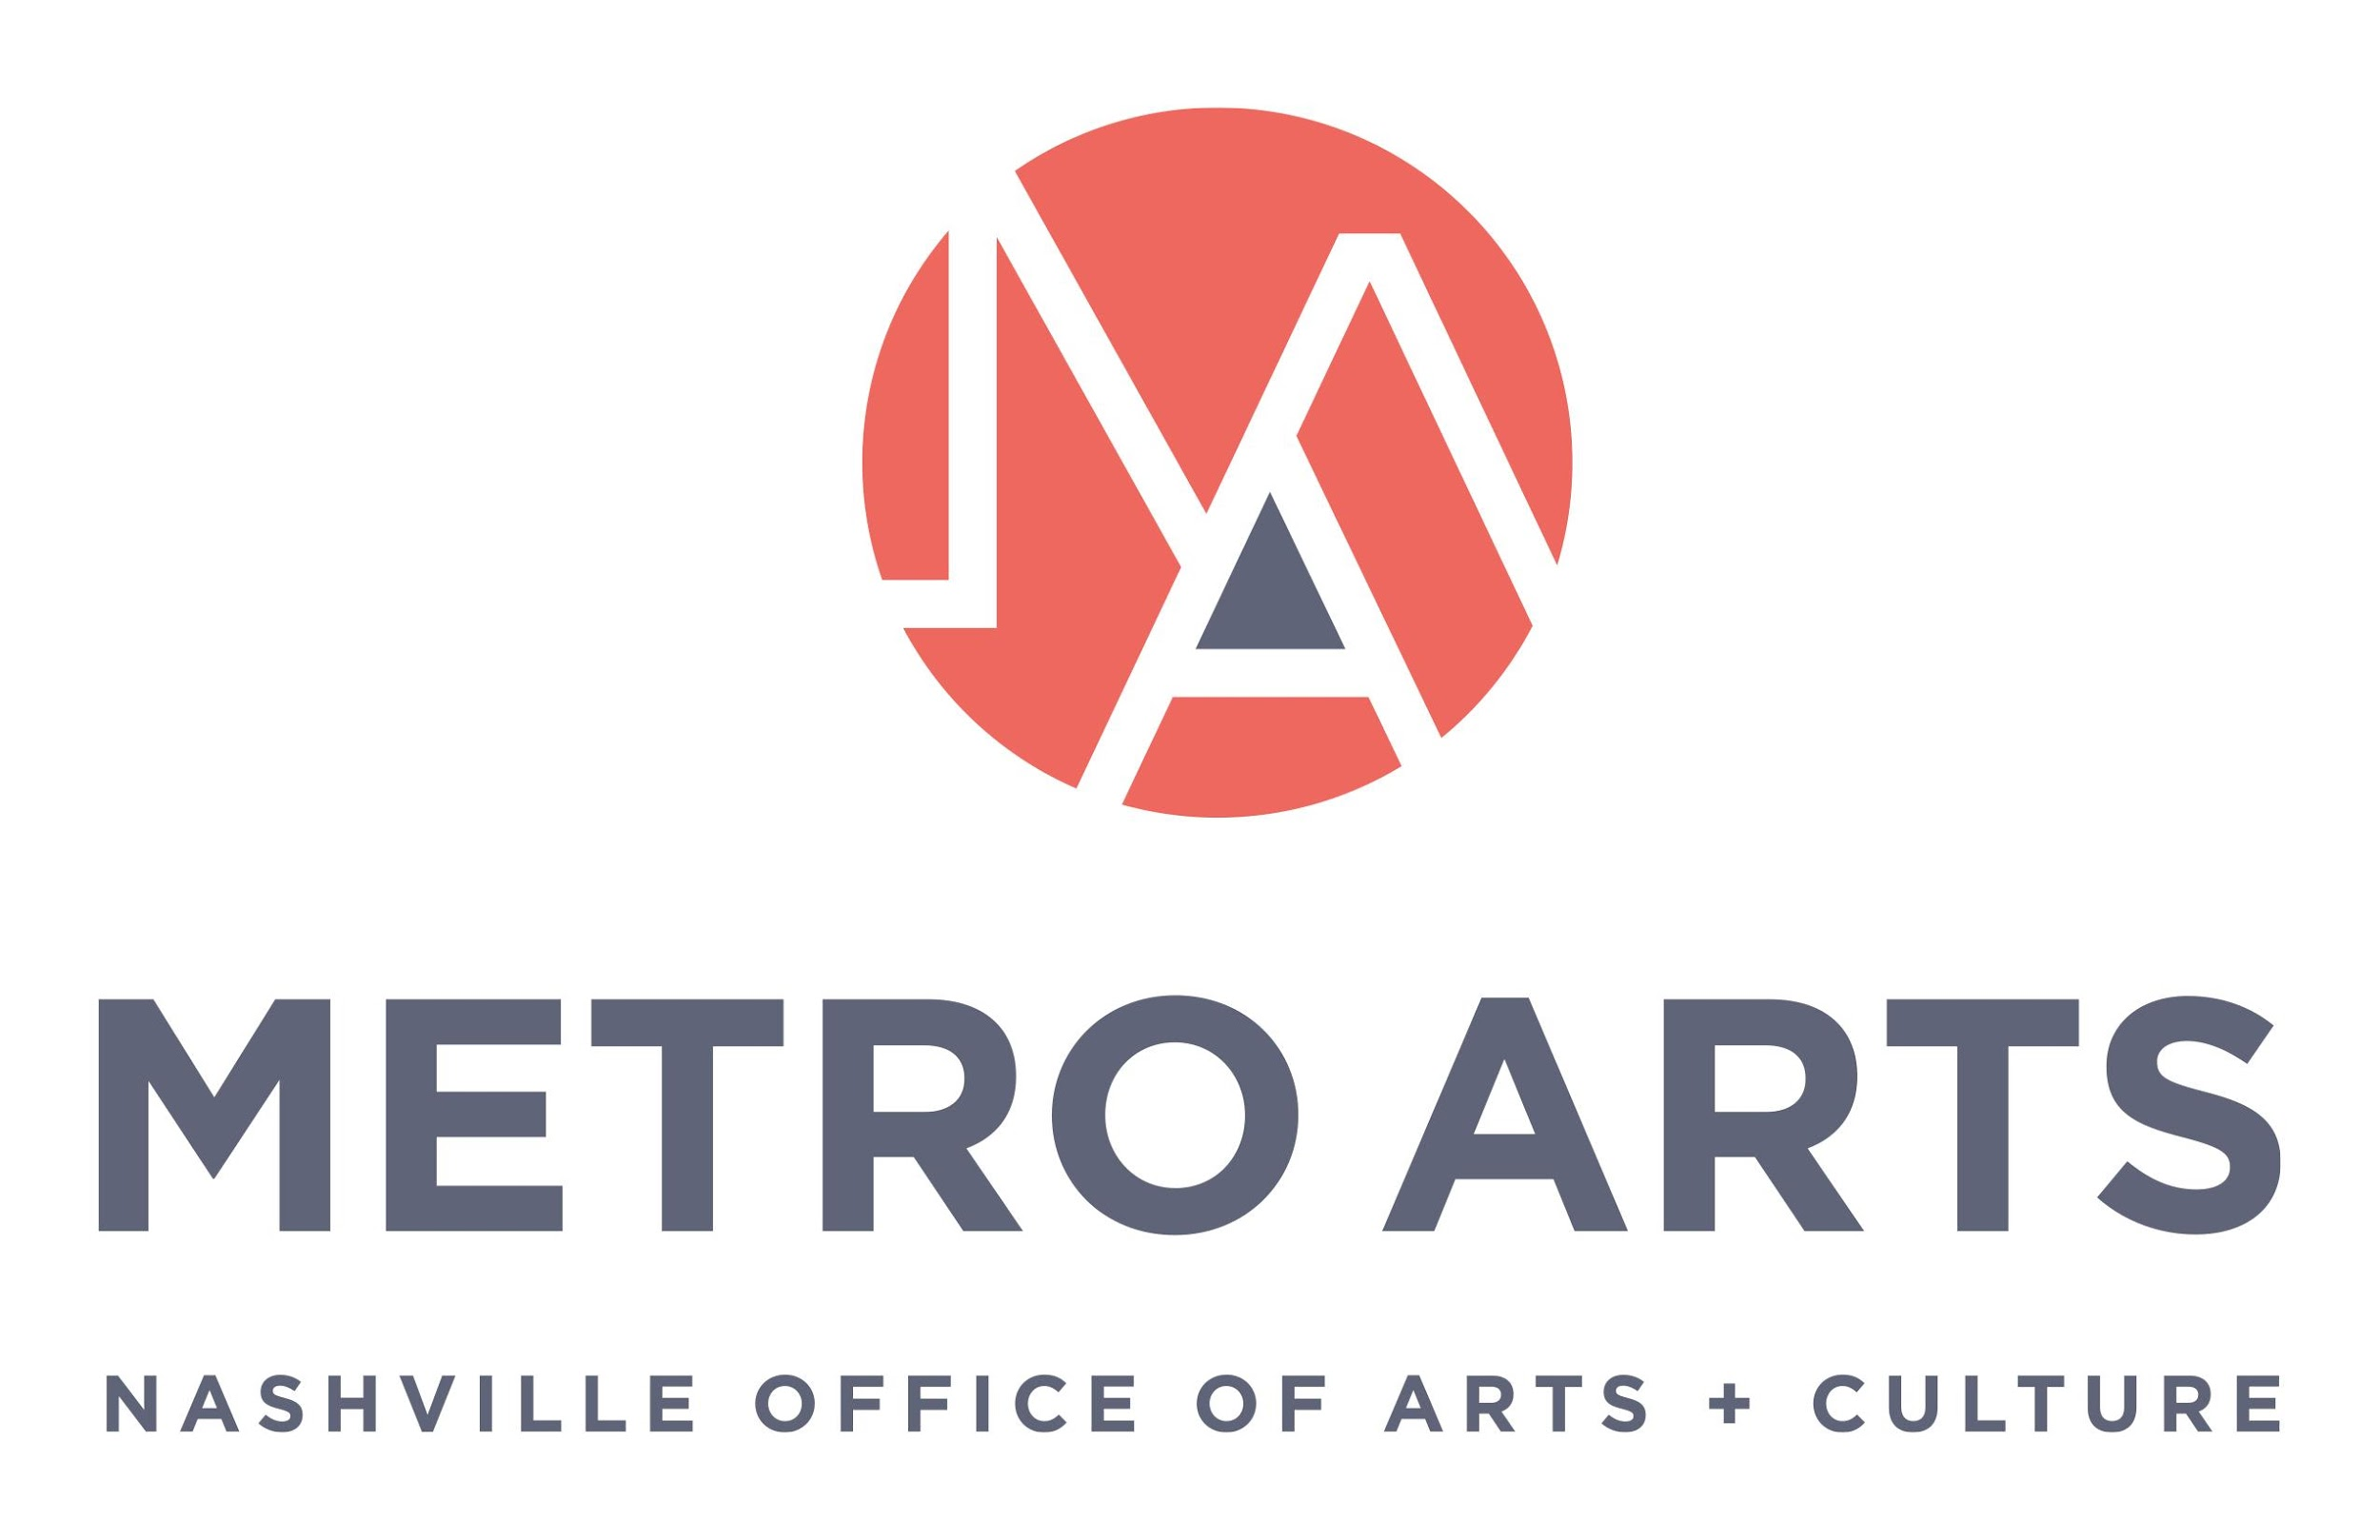

AGENDA
Committee for Antiracism and Equity Meeting
November 3, 2021 5:00-6:30 p.m.
Bordeaux Branch Library
Flex Room
4000 Clarksville Pike
Nashville, TN 37218

- Call to Order and Recognize Group Norms & CARE purpose statement
- Approval of Minutes: October 6, 2021
- Action/Discussion Items:
  - Review workflow strategy
  - Review Cultural Equity Statement
- Staff/ED/Commission Report
  - ASM Hiring Process update
  - CARE vacancies, recruitment/nomination process status update
  - Diversity in Arts Leadership Summer 2022
- Next Meeting & Planning
  - Temporary Art Guidelines Review
  - 2022 DIAL Selection Criteria
  - REAL Project Guidelines
- Adjourn meeting

