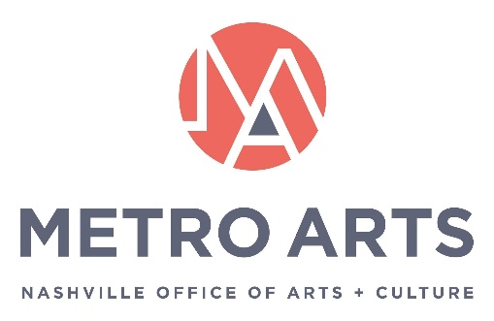

AGENDA
Metro Art Board of Commissioners
October 21, 2021 12-1:30 p.m.
Metro Southeast Building
Green Hills Auditorium
1417 Murfreesboro Pk.
Nashville, TN 37217

Commissioners: Jim Schmidt (Chair), Matia Powell (Vice Chair), Will Cheek (Sec. /Treasurer), Jane Alvis, Ellen Angelico, Dexter Brewer, Marianne Byrd, Bonnie Dow, Clay Haynes, Sheri Nichols Bucy, Marielena Ramos, Paula Roberts, Hope Stringer, and Campbell West

METRO ARTS MISSION:
Drive an Equitable and Vibrant Community through the Arts

- Call to Order & Welcome
- Approval of Minutes: September 16, 2020
- Arts in Action presentation
- Action Items:
  - CARE Roster
  - Summer 2022 DIAL Program
- CARE Report
- Executive Director’s Report
- Adjourn Meeting

