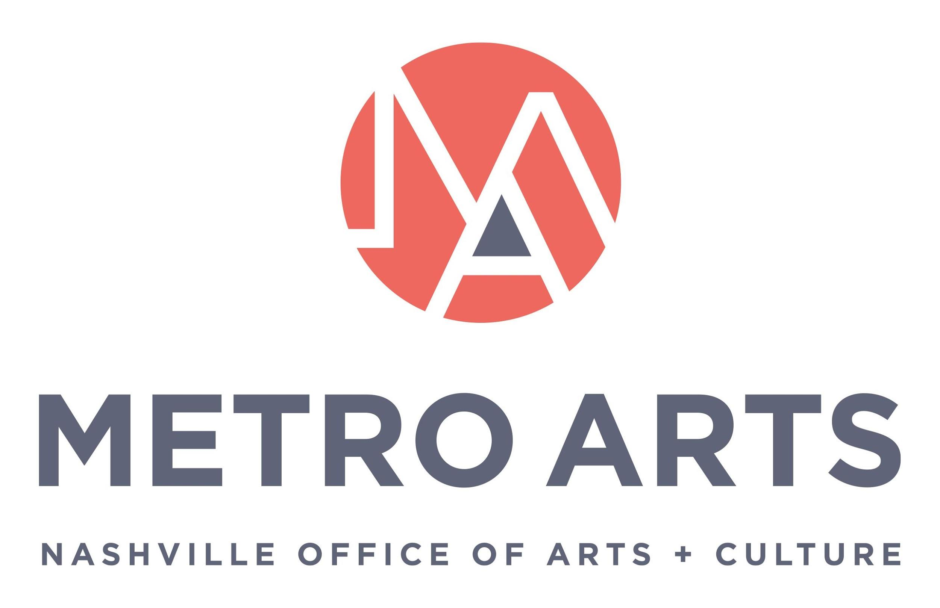

AGENDA
August 15, 2019, 12 p.m.
Metro Southeast – Madison Room
1417 Murfreesboro Pike

Commissioners: Jane Alvis, Will Cheek, Niki Coffman, Jackie Daniel, Manuel Delgado, Bonnie Dow, Clay Haynes, Sheri Nichols Bucy, Matia Powell, Marielena Ramos, Paula Roberts, Jim Schmidt, Hope Stringer, Campbell West and Marcus Whitney

METRO ARTS MISSION:
Drive an Equitable and Vibrant Community through the Arts

- CALL TO ORDER & WELCOME

- APPROVAL OF MINUTES: July 18, 2019

- ARTS IN ACTION: Highlights of Prior Month’s Activities

- ACTION Items:

- Bylaws
- Restorative Arts Program Guidelines
- ABC Grant Allocations
- Fairgrounds Selection Panelist Substitution

- Discussion
      - Antiracism Transformation Team (ARTt)

- Officers and Committees (ACTION)

- Program, Project and Operational Updates

- Adjourn Meeting

