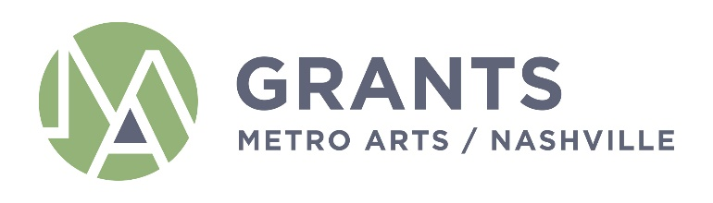

AGENDA
Grants and Funding Committee
Monday, November 8, 2021
12:30AM - 2:00PM
Metro Office Building
Nashville Room, 2nd Floor
800 2nd Ave S.
Nashville, TN 37210

If you have any questions, please e-mail arts@nashville.gov.

Committee: Sheri Nichols Bucy (Chair), Marianne Byrd, Bonnie Dow, Clay Haynes, Matia Powell, Marielena Ramos, Jim Schmidt (Ex-Officio)

Staff: Caroline Vincent, Janine Christiano, Grace Wright, Marysa LaRowe, Nichole Robinson

- Call Meeting to Order

- Approval of Minutes: September 13, 2021

- Presentation and Discussion of FY23 Grant Guidelines and Allocations Priorities

- Equity Lens Review

- Staff Report

- Set next Committee Meeting

- Adjourn

