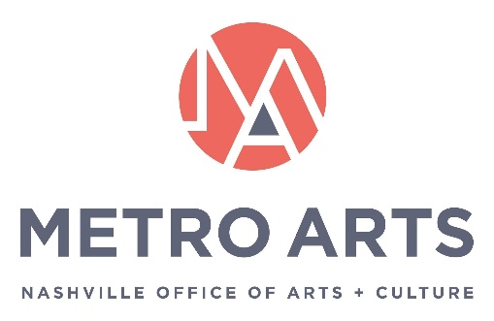

AGENDA
Metro Art Board of Commissioners
November 18, 2021 12-1:30 p.m.
Metro Southeast Building
Green Hills Auditorium
1417 Murfreesboro Pk.
Nashville, TN 37217

Commissioners: Jim Schmidt (Chair), Matia Powell (Vice Chair), Will Cheek (Sec. /Treasurer), Jane Alvis, Ellen Angelico, Dexter Brewer, Marianne Byrd, Bonnie Dow, Clay Haynes, Sheri Nichols Bucy, Marielena Ramos, Paula Roberts, Hope Stringer, and Campbell West

METRO ARTS MISSION:
Drive an Equitable and Vibrant Community through the Arts

- Call to Order & Welcome
- Approval of Minutes: October 21, 2021
- Arts in Action
- Action Items:
  - P.O.W.E.R. Youth Employment Guidelines (formerly Opportunity Now)
  - Donelson Public Art Selection Co-Chairs
  - Hire Above Base Rate
- CARE Report
  - Review Equity Lens questions
- Executive Director’s Report
  - Recognition of Service Awards and Longevity
- Adjourn Meeting

