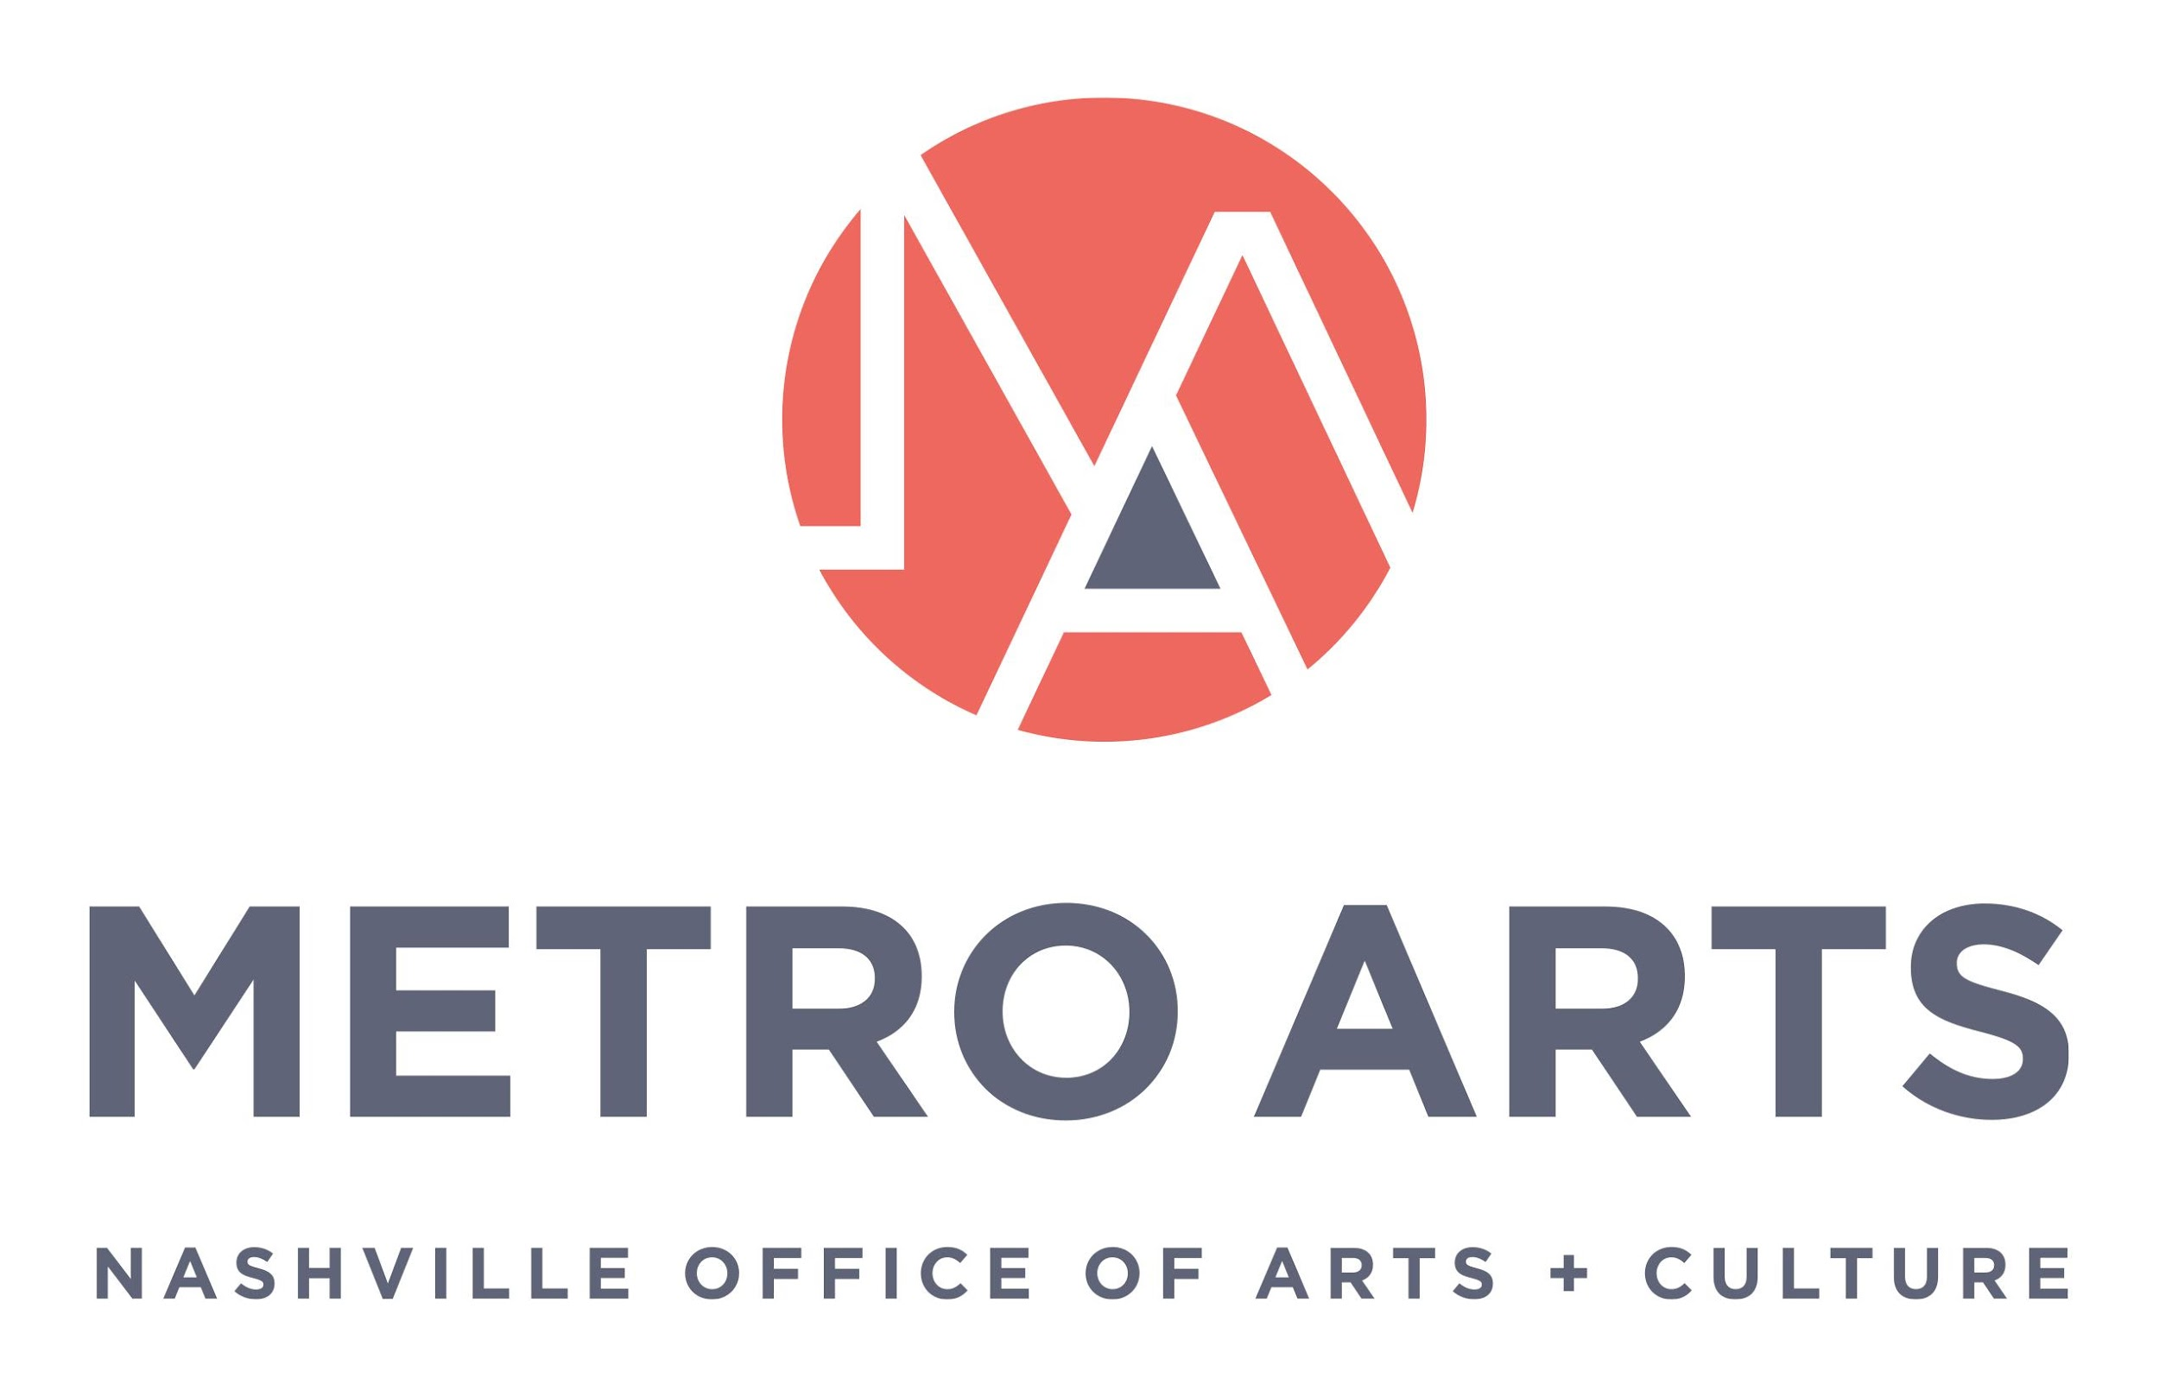

MINUTES
Committee for Antiracism and Equity Meeting
October 6, 2021 5:00-6:30 p.m.
Parthenon
Centennial Park
2500 West End Ave, Nashville, TN 37203

Committee Members Present: Ellen Angelico (Commissioner), Megan Kelley, Teree McCormick (ARTt Co-Chair), Paula Roberts (Co-chair, Commissioner), Jon Royal

Committee Members Absent: Sarah Bounse, Alandis Brassel, Will Cheek (Co-chair, Commissioner), Aaron Doenges, Ellen Gilbert

Staff: Caroline Vincent, Janine Christiano, Tré Hardin, Van Maravalli, Anne-Leslie Owens, Grace Wright

Guests: Erica Ciccarone, Isabel Tipton-Krispin, Theresa Dyer, Kats Berry

- Call to Order and Recognize Group Norms & CARE purpose statement

The meeting was called to order at 5:18 p.m.

The Committee welcomed the community members present and gave an overview of the purpose of the Committee. The CARE group norms and purpose were recognized.

Additionally, the Committee recognized the articles in the Nashville Scene and stated that while the issues cannot be discussed openly until the conclusion of the formal investigation, the Committee acknowledges that it is important to say that is happened and that it will be the work of the Committee.

- Approval of Minutes: September 1, 2021

A motion to approve the September 1, 2021 minutes was offered by Commissioner Angelico, Jon Royal seconded, and the motion passed.

- Discuss developing a process to manage and prioritize committee workload

The Committee discussed how to keep track of the many projects and priorities the body has set out to pursue especially in light of the difficulties caused by the pandemic. It was proposed that the Committee explore a digital option for process management such as Monday.com or Trello. The Committee additionally discussed potential concerns regarding Commissioners and Sunshine Laws and public access.

The Committee came to consensus that Megan Kelley would do further research into technical options and staff would confirm the legal feasibility.

- Discuss Commission request that CARE review all policy documents before approval

The Committee asked for clarification about this request from the Commission from staff.

Staff clarified that a question related to this topic came up at the last Arts Commission meeting. While there has been motivation to do this, it has not necessarily been formalized.

The Committee asked for clarification regarding when this process would begin and for more information about the number of documents as related to Committee capacity. Staff used the example the Temporary Art Guidelines to clarify that the review would focus on making sure that the guidelines align with Metro Arts’ stated equity values both in lens and language. They also clarified that there are not a large number of guidelines and would be happy to schedule them in a queue based on the Committee’s capacity. The Committee noted that there is importance in establishing consistency. It was proposed that this be discussed as a part of the continuing workflow discussion and that creating a schedule of guidelines review could help manage both Committee and staff capacity. This would also allow staff to make sure that they are budgeting in the proper amount of time in the review process.

- Review Temporary Art (on Metro Property) Guidelines

It was clarified that the issue with the Temporary Art Guidelines that came up in the Arts Commission meeting was one of semantics rather than process. However, given the importance of language, the Commission wanted to send to the Committee for review. This discussion is also tied into the language of Metro Arts’ Cultural Equity statement.

Van Maravalli presented an overview of the Temporary Art Guidelines, and the staff’s intentions to create a community facing and accessible document in partnership with other involved Metro departments.

The Committee came to consensus that the guidelines would be assigned to the external working group and reviewed by December 31st.

- Update on Equity Lens and Review of Metro Arts Cultural Equity Statement

The Committee introduced the draft of the Metro Arts’ Equity Lens questions and gave an overview of the tools’ purpose in the department’s equity work.

Janine gave an overview and update on the staff implementation of the Equity Lens and noted that staff hope this will be a continuous cycle with each implementation improving the tool.

The Committee discussed the process for reviewing staff and community comments about the equity lens and how the equity lens would be applied agency wide.

The Committee suggested that the equity lens be applied to another program very different from Thrive in another test round. The Committee discussed what would constitute an opposite program type from Thrive and potential program or project selections. The Committee noted the importance of hearing from un-trained users about challenges and implementation.

The Committee highlighted that there had also been discussion of creating supplemental materials such as definitions, a rubric, etc.

The consensus of the Committee was to ask the chairs of the other Commission Committees to utilize the draft equity lens questions for a project of their choosing and provide feedback on their experience to the Committee.

The Committee noted that in the implementation of this recommendation staff and committees could determine the process, but the Committee would ask for full participation and feedback.
The Committee also came to consensus on tabling the Equity Statement until the full Committee is present with the recognition that the language needs to match other policies should be a priority.

- Discuss CARE statement

The Committee stated that the point of this statement is that as discussion begins around recent events, the Committee felt it was necessary to reiterate the Committee’s purpose in terms of Metro Arts’ commitments to equity and restoration.

The Committee clarified that this was a statement to the Arts Commission and not the public. While the Committee recognized the importance of community voice and transparency, this statement serves a specific internal purpose. The Committee is working on how they fit into the intersection of community and government.

The Committee came to consensus that the draft statement has been thoroughly reviewed and was ready to send to the Executive Committee of the Arts Commission.

- Review CARE succession planning/upcoming vacancies/draft application

Staff will send update of confirmed members later in the week.

- Staff/ED/Commission Report

Executive Director and Staff did not have any updates.

- Review Caucusing Process and Planning

The Committee discussed the idea of caucusing publicly with CARE member facilitation so that Commissioners could be involved. The benefits of this would be to add community voices as well as centralize and humanize the work in these conversations. Staff will check into the potential legal restrictions on meetings like this.

- Adjourn meeting

The meeting was adjourned at 6:35 p.m.

