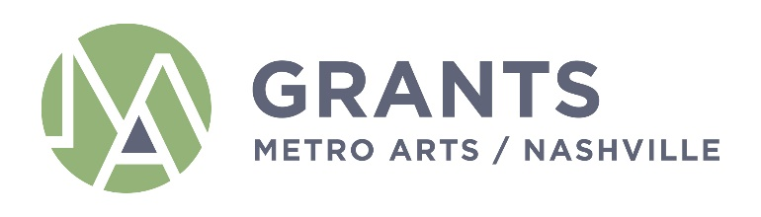

MINUTES
Grants and Funding Committee
Monday, November 8, 2021
12:30AM - 1:30PM
Metro Office Building
Nashville Room
800 2nd Ave S.
Nashville, TN 37210

If you have any questions, please e-mail arts@nashville.gov.

Committee Members Present: Jim Schmidt (Ex-Officio), Sheri Nichols Bucy (Chair), Marianne Byrd, Bonnie Dow, Clay Haynes, Matia Powell, Marielena Ramos

Staff: Janine Christiano, Marysa LaRowe, Grace Wright

- Call Meeting to Order

The meeting was called to order at 12:44 p.m.

- Approval of Minutes: September 13, 2021

A motion to approve the minutes from September 13, 2021 was offered by Commissioner Byrd, Commissioner Dow seconded, the motion passed.

- Presentation and Discussion of FY23 Grant Guidelines and Allocations Priorities

Janine Christiano presented an overview of the FY23 Grant Guidelines and proposed changes. She presented the Committee with guiding questions for the discussion:
- Is a new category, B4, for organizations between $100-$400K needed?
- What percentage of the total grants budget should the Arts Commission commit to each category (Basic and Core)?
- How should endowments, rental income, etc be factored in to scoring and allocations decisions, if at all?

The Committee discussed the increase in arts organizations and the potential effects of funding models on the different categories. The Committee also discussed the overall impact of grantee organizations and how funding decisions relate to the Arts Commission’s mission.

The Committee discussed how to help arts organizations become self-sustaining and how these conversations fit into the upcoming strategic planning process. The committee expressed that they would like to hold off making any drastic decisions before that process had been completed.

The Committee requested that staff provide further information about funding, impact, and participants.

- Equity Lens Review

Janine Christiano presented the Committee with a request from the Committee for Antiracism and Equity that each of the Arts Commission Committees participate in helping to test a proposed Equity Lens document by applying it to a Committee decision.

Chair Bucy proposed that the Committee apply it to the allocations process for this initial test of the tool and process.

The Committee discussed how this would be implemented and the goals related to this process. The Committee expressed some concerns about how the process would work but decided to review the materials and continue discussion at the December meeting.

- Strategic Funding and Initiatives (SFI) Team – Program Updates

Janine Christiano gave an update on the POWER Youth program partnership and let the Committee know that the Site Partner guidelines would be presented at the Arts Commission meeting on November 18th.

- Set next Committee Meeting

The next Grants & Funding Committee was tentatively set for Tuesday, December 7th.

- Adjourn

The meeting was adjourned at 1:50 p.m.

