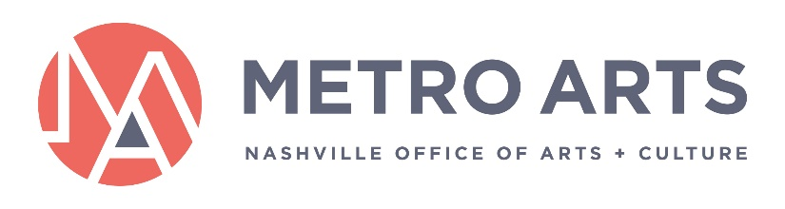

MINUTES
Public Art Committee
September 9, 2021 2:00PM-3:30PM
Metro Office Building
Nashville Room
800 2nd Ave S
Nashville, TN 37210

If you have any questions, please e-mail arts@nashville.gov.

Committee Members Present: Jane Alvis (Chair), Omari Booker, Shaun Giles

Committee Members Absent: Sara Lee Burd, Campbell West (Commissioner), Donna Gilliam, Jim Schmidt (ex-officio)

Staff: Van Maravalli, Tré Hardin, Atilio Murga, Anne-Leslie Owens, Emily Waltenbaugh, Grace Wright, Marysa LaRowe

Guests: Ariana Hodes, Anne Veal

- Call to Order

The meeting was called to order at 2:13 p.m.

- Approval of Minutes: August 11, 2021

Chair Alvis asked if there were any questions or changes to the minutes.

A motion to approve the minutes from August 11, 2021 was offered by Omari Booker, Shaun Giles seconded, the motion passed.

- Welcome

Chair Alvis welcomed back Van Maravalli from maternity leave.

Van Maravalli thanked the staff and Committee for all their hard work in her absence.

- Action Items:

  - FY22 Cycle 1 Thrive Allocations (Public Art)

Marysa LaRowe presented the Committee with the proposed FY22 Cycle 1 Thrive projects with public art elements. Marysa reminded the Committee that this cycle covers artist-led, community-based projects. The community-led panel recommend to following allocations:
- Creative Girls Rock Mobile Mural Project (Public Art Project)
  - Lead Artist: Donna Woodley
  - Community Partners: Creative Girls Rock
  - Community or Neighborhood Served: North Nashville, moving to neighborhoods around Nashville
  - Request Amount: $9,500
  - Recommended Award Amount: $9,500*
    - *Conditional Award: Staff recommend this project for funding provided the necessary conditions can be met.
- Paragon Mills Elementary and Community Mural (Public Art Project)
  - Lead Artist: Nuveen Barwari, supporting artist Woke3
  - Community Partners: Freedom Arts Collective, Paragon Mills Elementary School*
  - Community or Neighborhood Served: Paragon Mills (Antioch)
  - Request Amount: $9,500
  - Recommended Award Amount: $9,500
- Jardines de Color/Colorful Gardens (Public Art Project)
  - Lead Artist: Andrés Bustamante
  - Community Partners: Personal Contemporary Artist Collective, Merengue Café
  - Community or Neighborhood Served: South Nashville, Antioch
  - Request Amount: $9,500
  - Recommended Award Amount: $9,500*
    - *Conditional Award: Staff recommend this project for funding provided the necessary conditions can be met.
- Now and When: Love Letters to Nashville (Public Art Project)
  - Lead Artist: Lindsey Laseter
  - Community Partners: Nashville Design Week
  - Community or Neighborhood Served: Lower Broadway/2nd Ave
  - Request Amount: $9,500
  - Recommended Award Amount: $9,500

Chair Alvis asked if there were any questions or discussion regarding the action item.

The Committee asked for clarification regarding the additional conditions for funding and whether it would present budgetary concerns for the project. Staff clarified that they will work with applicants to meet these conditions within budget and get additional clarifications for coaching from staff.

A motion to approve the FY22 Thrive Cycle 1 public art project allocations was offered by Commissioner Alvis, Shaun Giles seconded, the motion passed.

  - Donelson Library Selection Panel Slate

Anne-Leslie Owens presented the Committee with the proposed community selection panel for the Donelson Library public art projects approved by the Committee and the Arts Commission in August.

Chair Alvis asked if there were any questions or discussion regarding the action item.

The Committee asked for clarification about the size of the selection panel. Staff clarified that they would be aiming to create a seven-person panel given the scope of the project and the Public Art Guidelines.

A motion to approve proposed slate of voting and non-voting members for consideration for the Donelson Library Public Art Selection Panel(s) and give staff authority to finalize panel(s) based on panelist interest and availability to serve was offered by Shaun Giles, Omari Booker seconded, the motion passed.

  - Fairgrounds Public Art Concept

Atilio Murga presented the Committee with a recap of the Fairgrounds Project and the first stage of the public art concept. Blessing Hancock, the artist, will be developing the second element through continued community engagement and with the help of her local mentee, Miriam Speyer.

Chair Alvis asked if there were any questions or discussion regarding the action item. There was none.

A motion to approve Blessing Hancock’s design for permanent public art at the Nashville Fairgrounds was offered by Commissioner Alvis, Omari Booker seconded, the motion passed.

- Project and Program Updates

Van Maravalli gave the Committee updates on public art policy work, contracting in progress, and partnerships with other Metro departments.

Staff did not have any current project or program updates.

- Adjourn

The meeting was adjourned at 2:44 p.m.

