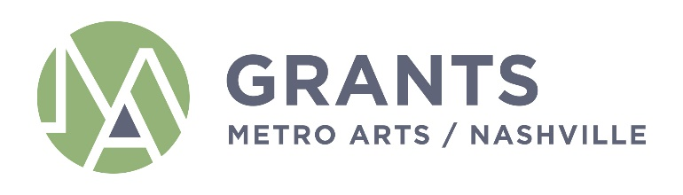

AGENDA
Grants and Funding Committee
Monday, January 10, 2021
1:00PM - 2:30PM
Metro Office Building
Nashville Room

If you have any questions, please e-mail arts@nashville.gov.

Committee: Sheri Nichols Bucy (Chair), Marianne Byrd, Bonnie Dow, Clay Haynes, Matia Powell, Jim Schmidt (Ex-Officio)

Staff: Caroline Vincent, Janine Christiano, Grace Wright, Marysa LaRowe, Nichole Robinson

- Call Meeting to Order

- Approval of Minutes: December 7, 2021

- POWER Youth Site Partner Awards

- Staff Report
  - ASO2 Hiring process update
  - Other Staff Updates

- Set 2022 Committee Meeting Schedule

- Adjourn

