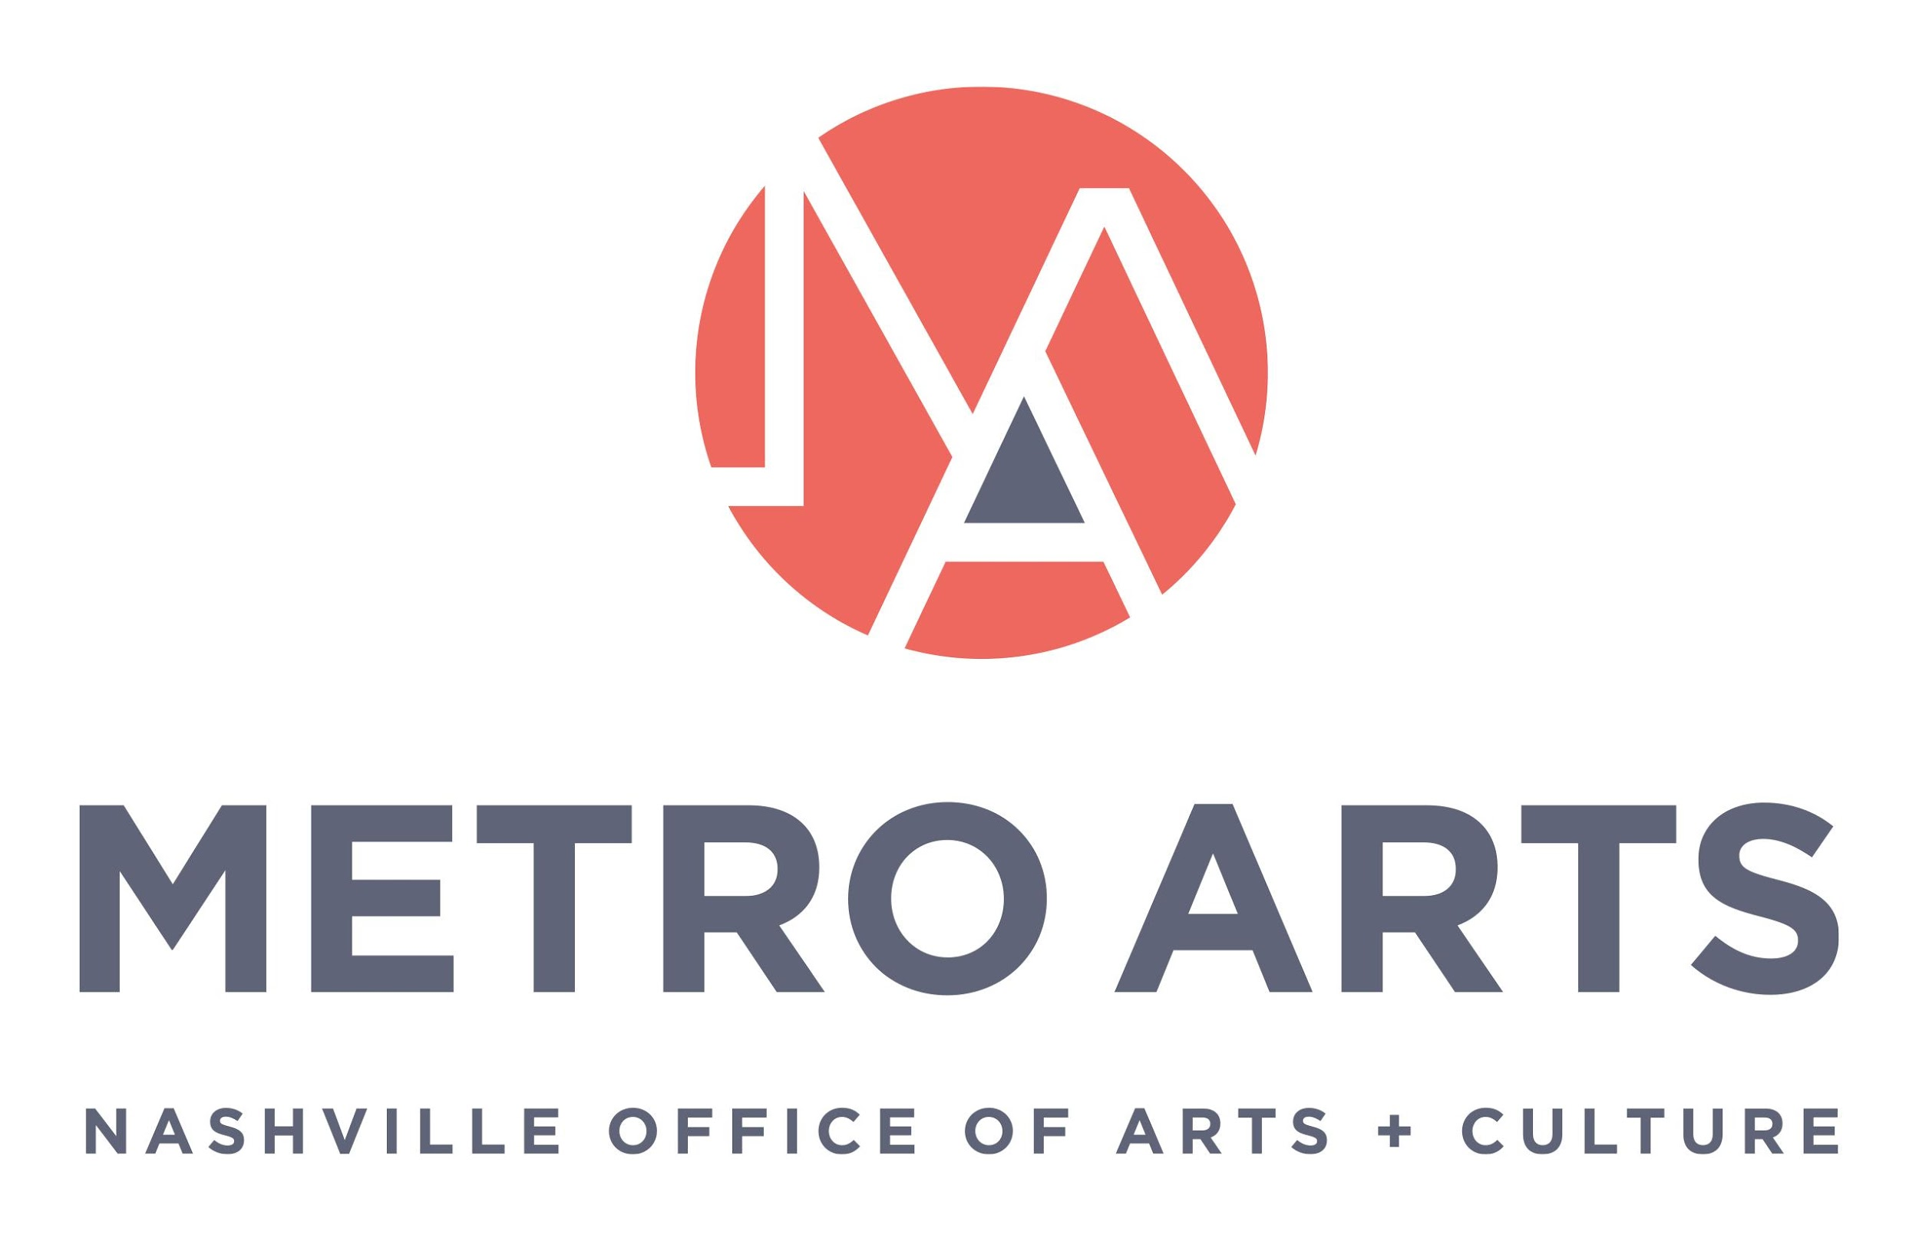

AGENDA
Committee for Antiracism and Equity Meeting
January 12, 2022 5:00-6:30 p.m.
East Park Community Center
Large Club Room
700 Woodland St.
Nashville, TN 37206

- Call to Order and Recognize Group Norms & CARE purpose statement
- Approval of Minutes: December 1, 2021
- Action/Discussion Items:
  - CARE Community Member Application Review
  - New member onboarding process
  - 2022 DIAL Selection Criteria
  - Public Comment Policy
- Staff/ED/Commission Report
  - Hiring Process Update
  - Strategic Planning Update
- Next Meeting & Planning
- Adjourn meeting

